**Objectives**

* Explain various ways of conditional rendering
* Explain how to render multiple components
* Define list component
* Explain about keys in React applications
* Explain how to extract components with keys
* Explain React Map, map() function

In this hands-on lab, you will learn how to:

* Implement conditional rendering in React applications

**Prerequisites**

The following is required to complete this hands-on lab:

* Node.js
* NPM
* Visual Studio Code

**Notes**

Estimated time to complete this lab: **60 minutes.**

Create a React App named “bloggerapp” in with 3 components.

1. Book Details
2. Blog Details
3. Course Details

Implement this with as many ways possible of Conditional Rendering.

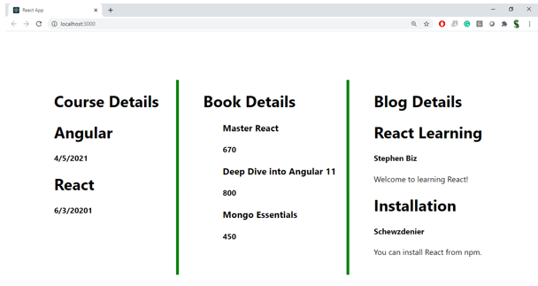

**Hint:**

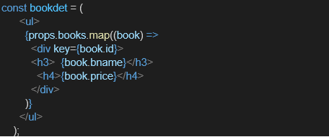

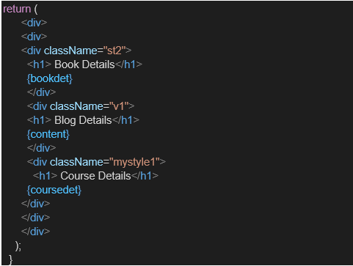

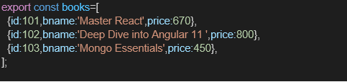

import React from 'react';

const blogs = [

  { id: 1, title: 'Understanding React', author: 'Anjali' },

  { id: 2, title: 'JavaScript Tips', author: 'Rahul' }

];

const BlogDetails = () => {

  return (

    <div>

      <h2>Blog List</h2>

      <ul>

        {blogs.map(blog => (

          <li key={blog.id}>

            {blog.title} - <i>{blog.author}</i>

          </li>

        ))}

      </ul>

    </div>

  );

};

export default BlogDetails;

import React from 'react';

const books = [

  { id: 1, title: 'Atomic Habits', author: 'James Clear' },

  { id: 2, title: 'Ikigai', author: 'Francesc Miralles' },

  { id: 3, title: 'Deep Work', author: 'Cal Newport' }

];

const BookDetails = () => {

  return (

    <div>

      <h2>Book List</h2>

      {books.map(book => (

        <BookItem key={book.id} book={book} />

      ))}

    </div>

  );

};

const BookItem = ({ book }) => {

  return (

    <div>

      <p><strong>{book.title}</strong> by {book.author}</p>

    </div>

  );

};

export default BookDetails;

import React from 'react';

const blogs = [

  { id: 1, title: 'Understanding React', author: 'Anjali' },

  { id: 2, title: 'JavaScript Tips', author: 'Rahul' }

];

const BlogDetails = () => {

  return (

    <div>

      <h2>Blog List</h2>

      <ul>

        {blogs.map(blog => (

          <li key={blog.id}>

            {blog.title} - <i>{blog.author}</i>

          </li>

        ))}

      </ul>

    </div>

  );

};

export default BlogDetails;

